**Docker**

**1: Creating Dockerfile for Python App**

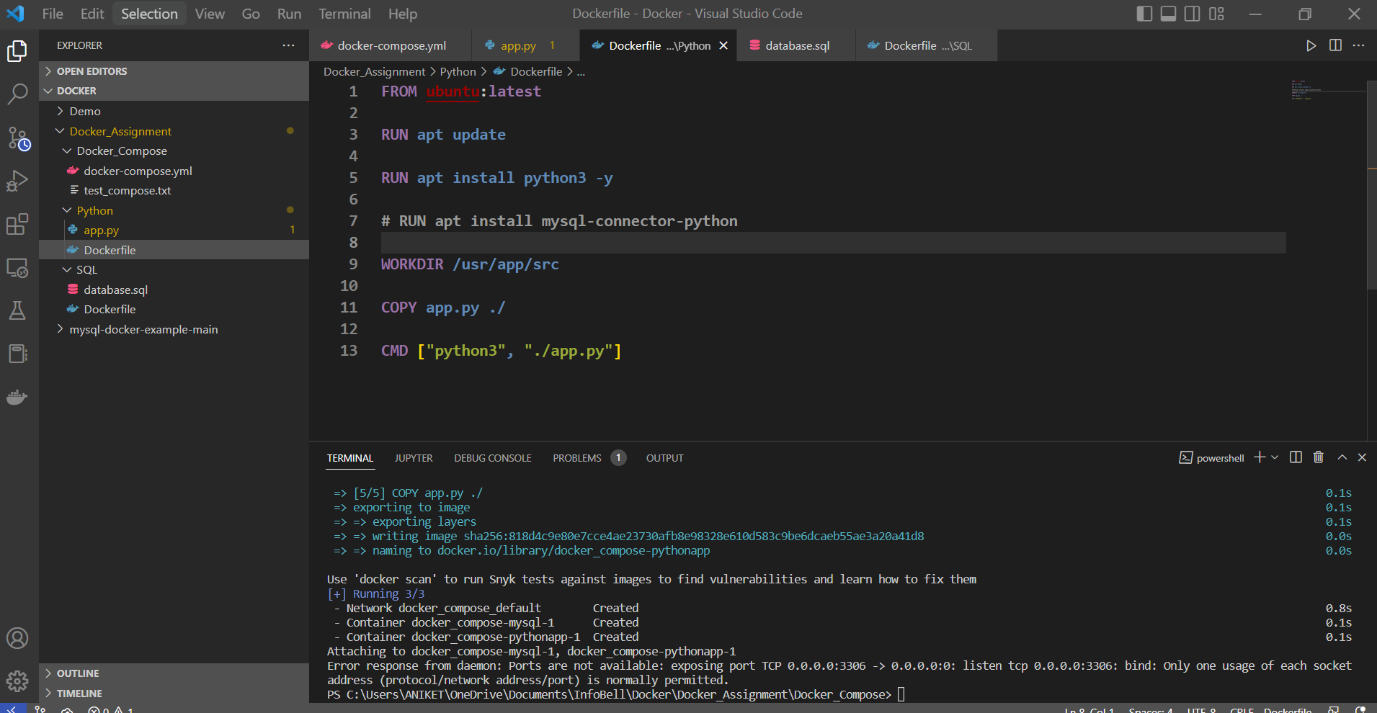

**2: Creating app.py file**

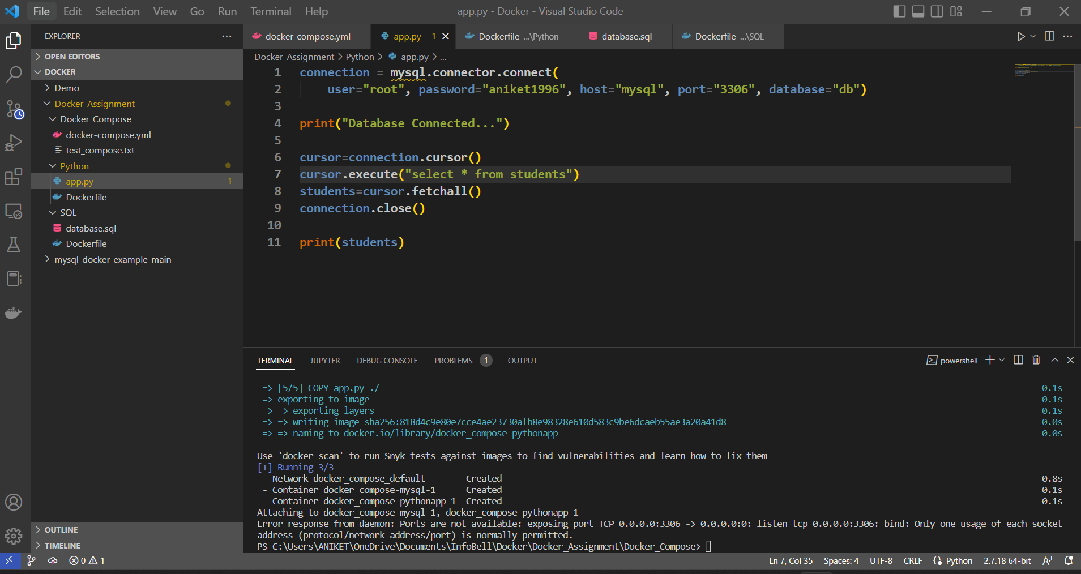

**3: Creating Dockerfile for MySQL**

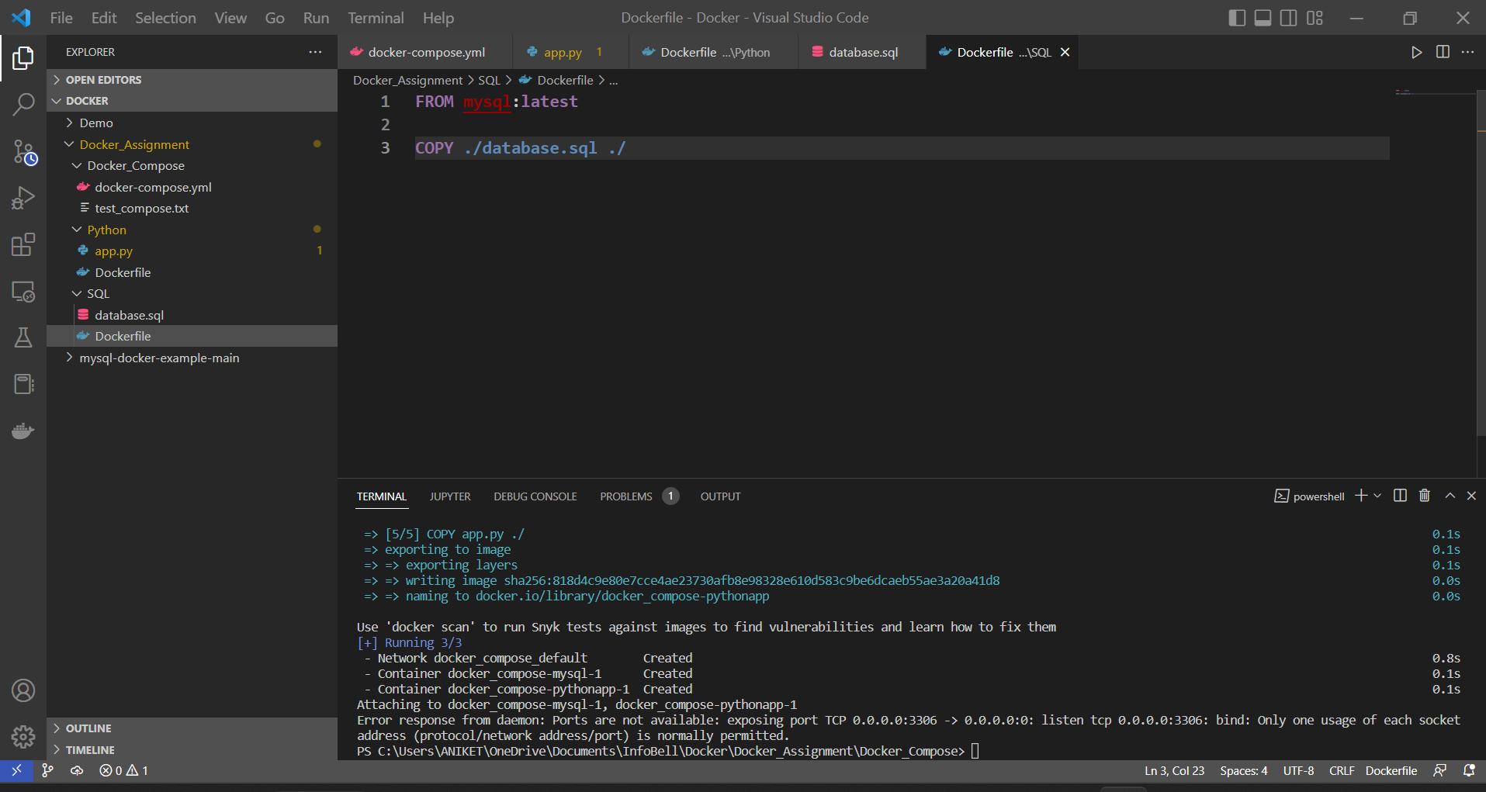

**4: Creating schema file**

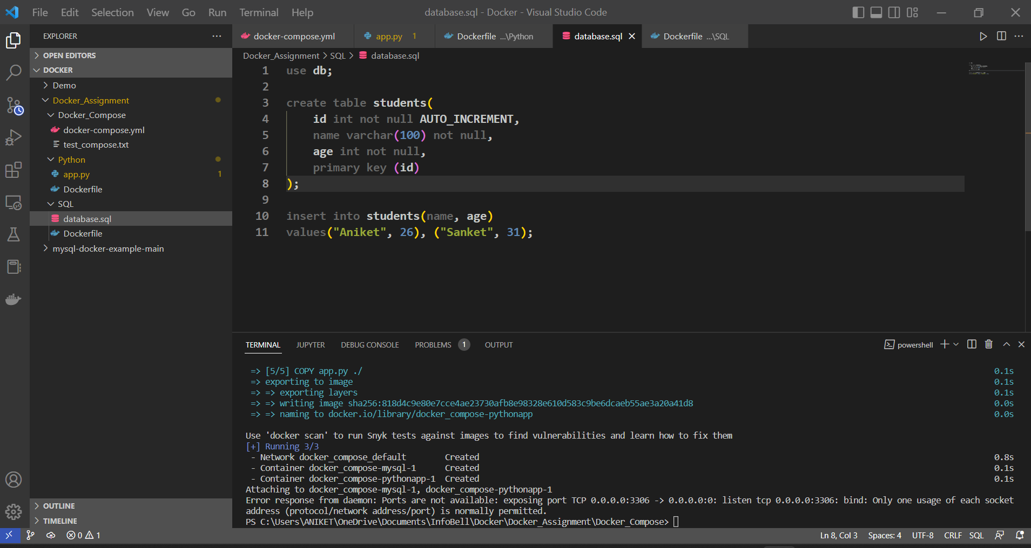

**5: Creating Docker-Compose.yml file**

